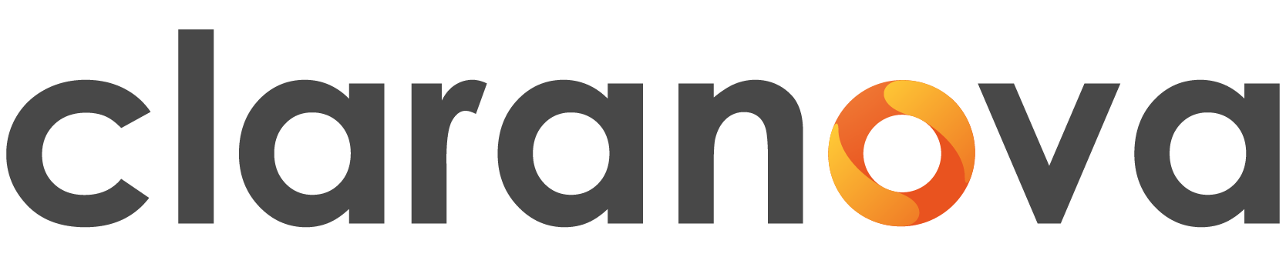

Signing of a strategic distribution agreement with Vertosoft
Claranova accelerates the growth of Avanquest’s B2G* business in the U.S. public sector market

Paris, France – August 19, 2026 - 6:00 pm CET. Claranova (Euronext Growth Paris: FR0013426004 - ALCLA) is taking a new step in the development of its business in the United States with the signing, by its Avanquest division, of a distribution agreement with Vertosoft. This partnership gives the Group access to the portfolio of government contracts held by one of the leading distributors of technology solutions to the U.S. public sector. This agreement will be highlighted at the NIGP Forum 2026(**), August 23–26 in Columbus, Ohio.

The contract grants Avanquest immediate access to more than 90,000 U.S. public agencies in the SLED(***) (State, Local & Education) sector, for PDF solutions within Vertosoft’s portfolio. It demonstrates Claranova’s proactive strategy to accelerate Avanquest’s B2B business by expanding distribution channels that generate recurring revenue. This selection also highlights the ability of the artificial intelligence and automation solutions developed by Avanquest’s teams to meet the requirements of a leading player in the U.S. public sector.

Avanquest reaches a key milestone in the U.S. public sector market

Avanquest’s listing with OMNIA Partners and Sourcewell gives it direct access to the U.S. SLED market, which includes government agencies, local governments, and educational institutions.

These two networks cover nearly 95% of the addressable market and enable public entities to procure Avanquest’s solutions through pre-negotiated cooperative agreements, reducing contract negotiation times from several months to just a few days.

With this distribution agreement, Avanquest significantly strengthens its position in the U.S. public sector market and joins the ranks of major technology players already listed with public entities.

A new growth driver for the B2B business

This distribution agreement—which does not require the establishment of a dedicated sales organization—significantly expands the addressable market for Avanquest’s document management and automation solutions. These solutions will enable organizations to modernize their document processes while integrating with their existing IT infrastructures.

For Claranova, this partnership is fully aligned with the Group’s new strategy, which prioritizes the development of its B2B business as a key growth area. It thus opens up a new growth driver by expanding the reach of Avanquest’s proprietary technologies through a scalable distribution model designed to accelerate the growth of recurring B2B revenue and gradually increase its contribution to the Group’s revenue.

“This partnership with Avanquest perfectly reflects our mission: giving U.S. public sector organizations simple, fast access to innovative technology. By adding Avanquest’s PDF solutions to our portfolio, we’re enabling state, local, and education agencies to modernize their document workflows through faster, more streamlined procurement. It’s a powerful example of the value Vertosoft delivers to both our technology partners and the public sector organizations we serve every day.”

Jay Colavita, President and Founder of Vertosoft

« This agreement creates real value for both government agencies and Claranova. Public agencies now have quick and easy access to secure, flexible document management solutions tailored to their needs, through a procurement channel already widely recognized by U.S. government agencies. For Claranova, this agreement serves as a powerful growth driver, enabling us to strengthen our presence in a strategic market and accelerate the growth of our recurring B2B business, which is at the heart of our new strategy..»
Eric Gareau, CEO of Claranova

(*) B2G: “Business to Government” refers to commercial relationships between a private company and a public entity (ministry, local government, hospital, etc.), governed by public procurement and competitive bidding processes
(**) NIGP Forum: annual event organized by NIGP—The Institute for Public Procurement, the leading association for public procurement professionals in the United States
(***) SLED: State, Local & Education—U.S. public sector organizations (states, local governments, and educational institutions)

Financial calendar:
October 21,2026: 2025-2026 Annual Results
November 10, 2026: Revenue for the three-month period ended September 30, 2026
December 4, 2026 : Annual General Meeting

Telephone number for individual shareholders available from Tuesday to Thursday between 2 p.m. and

4 p.m. for calls within France: 0805 29 10 00 (local rate).

About Vertosoft:
At Vertosoft, we are a trusted, value-driven distributor of innovative technology solutions. Our experienced team and tailored services equip our channel partners and suppliers with the tools, contracts, and secure systems needed to succeed in the public sector market.
For more information, visit Vertosoft.com.
About Claranova:
Claranova is an innovative SaaS software publisher focused on simplifying everyday digital use across the Document (PDF), Utilities & Security, and Photo segments. Its solutions are marketed in more than 160 countries, with 94% of revenue generated outside France, and incorporate the latest artificial intelligence technologies to harness data, automate usage, and enhance the user experience. Offered in multiple versions and languages, its products are built on highly recurring revenue models.
Building on its strong and well-established B2C customer base, Claranova is accelerating its expansion in B2B by leveraging its proprietary technology platforms to address growing demand for workflow management and optimization.

Claranova is eligible for French “PEA-PME” tax-advantaged savings accounts
For more information on Claranova Group:
https://www.claranova.com or https://x.com/claranova_group

